Jonny Hughes

Software Testing

Weekly Progress 11

* Multiple files at 100%(1)
  + 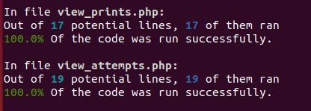
  + 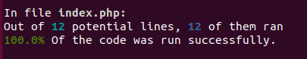
  + 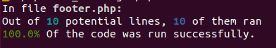
* Overall percentage 85%(1)
  + 
* Data in database(1)
  + ['/test_attempt.php?id=22', 'Judge Submission', "admin", "secret"],
  + This test verifies that acertain id in the database is seen when logged in as admin on test_attempt page
  + ["/edit_contests.php", "2", "admin", "secret"],
  + This verifies that a created contestant is seen on the edit_contests page
* Conditional Content(2)
  + ["/view_problems.php", "Judge Menu", "admin", "secret"],
  + This verifies the viewing of the Judge Menu
  + ["/edit_contests.php", "2", "admin", "secret"],
  + This verifies that a created contestant is seen on the edit_contests page only if the judge is logged in.
* Absence of conditional content(2)
  + ["/edit_notes.php", "refresh", "", ""],
  + ["/edit_problems.php", "refresh", "notJudge", "aaa"],
  + This makes sure content such as the judge only pages like edit_notes and edit-problems can not be seen if not logged in or as a non-judge
* New Bug/Unit test finding it(2)
  + See Github, I found a piece of code in login which should be reachable but due to a mistake was unable to be reached.
  + This was found by this test not reaching those lines of code in login
  + ['Sample Login', '', '', '/login.php', ['user'=>'admin', 'password'=>'']],
* See my Repo for commits, should be multiple.(1)